PYTHON BASIC NOTES

Introduction to Python:

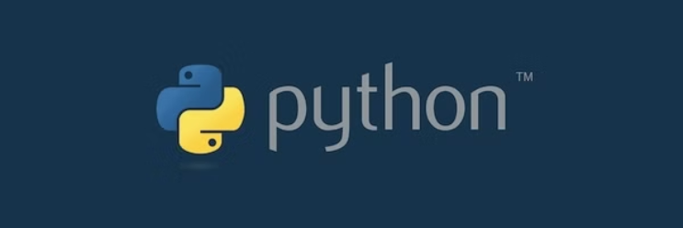

* **Python is a popular, easy-to-learn, and very powerful programming language, which is used in software and web development, data science, machine learning, and many other fields.**
* **In this course, we’ll cover the basic concepts of Python, as well as build real-life projects and solve different coding challenges.**
* **Python for Beginners requires no prior programming experience, so let’s dive right in!**
* **Python is one of the most popular programming languages in the world. It’s widely used in web and game development, data analytics, data science, machine learning, and much more.**
* **Python has a simple syntax, which means that it’s easier to learn. In this course you’ll start coding your own programs in no time, so you can solve real-world problems and build your own applications.**
* **I utilized Anaconda Navigator and Jupyter Notebook software to write and execute Python programs, applying fundamental concepts such as variables, loops, and conditional statements to analyze and manipulate data efficiently.**
* **"Kaggle, a popular platform for data science enthusiasts, provides invaluable resources and support for Python-related project creation, offering datasets, competitions, and collaborative environments to hone skills and tackle real-world challenges."**

**INTRODUCTION TO JUPYTER NOTEBOOK :**

**#Introduction to jupyter Notebook**

**CODE BASED COMMENTS**

**#step1 :print("my hero daddy")**

**OUT PUT**

**my hero daddy**

**#step2 : name="Revathi"**

**print(name)**

**OUT PUT**

**Revathi**

**#step3 :print(5+5)**

**OUT PUT**

**10**

**Markdown based**

**step4**

**###Introduction to jupyter Notebook**

**## Heding 2 [ Medium size ]**

**### H3**

**#### H4#**

**##### H5**

**OUT PUT**

**Heding 2 [ Medium size ]**

**H3**

**H4**

**H5**